Java Programming -II Div A
Date:28th December 2019

Write a program in JAVA that will create two threads to display the following:
Example:

Thread1 handle one string “java” Thread2 handle another string “thread” and Output should be “jathvaread”

Write a java applet program to create multithreads in java using Runnable interface to do the following on the number taken from user and set priorities to various threads:

  - One thread display each digit of the inputted number
  - Second thread display reverse of the inputted number
  - Third thread display sum of each digit of the inputted number

Write a program that create 2 threads – each displaying a message (Pass the message as a parameter to the constructor). The threads should display the messages continuously till the user presses ctrl-c. Also display the thread information as it is running.

Java Programming-II
Ass -2 Div A
Date :4th January 2020
- Develop a java program with user login form to authenticate the user through the database.

- Write a java applet program to Check if a given String is Palindrome

2.Create following form in java Applet
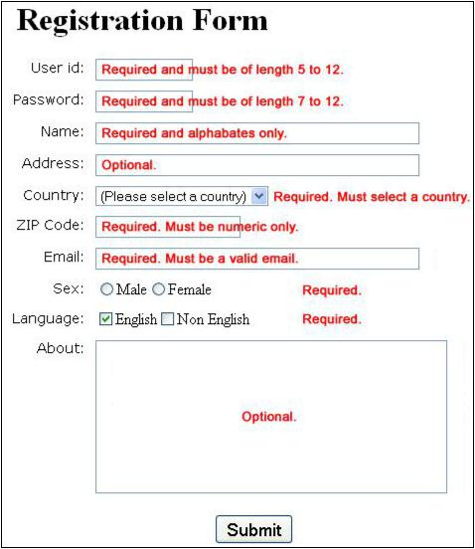

Java Programming II DivA
Aim :Applet Ass 3
Date:18th January 2020

Write a java applet program which has three radio buttons, on click of any radio button perform the following:

a) 1st radiobutton it will draw triangle,
b)2nd radiobutton it will draw rectangle

c)3rd radiobutton it will draw oval shape.

Write a java applet program which has 3 buttons, on click it generates different graphical shapes. Take a list box which displays different colours. On selection of the colour, the object should be filled by that colour.

Write a java applet program which perform STACK operation (push and pop ) by clicking on buttons(push and pop) displaying stack elements in LISTBOX .

Develop an applet that display the position of the mouse at the upper left corner of the applet when it is dragged or moved. Draw a rectangle filed with black at the current mouse position.

Aim : JDBC and Applet
- Develop a java program with user login form to authenticate the user through the database.

- Write a menu driven program (Command line interface) to perform the following operations on student table. 1. Insert 2. Modify 3. Delete 4. Search 5. View All 6. Exit

Aim:JSP and Servlet, JDBC
Note:Session Management with JDBC

Write the program for jsp and servlet to read n from user and return average of 1 to n numbers

Develop a simple JSP and servlet program for user registration page and then redirects the user on login page if registration is successful.

Develop a simple JSP and servlet program with user login form to authenticate the user through the database.

Consider the above program with state management. After login, Develop a JSP and servlet program to display the list of products in the drop down menu (products fetched from the table) and display the selected product information.

Developed a JSP and Servlet page to order above selected product, display detail for the same and insert data into relevant table.
Also display product wise all information in proper format.

